- Light Posts in Arcata
By: Christine Adema, Thomas Alexander, and Nathaniel Douglass
12th of May, 2016

Abstract
The goal of this project was to locate light posts on the campus of Humboldt State University, as well as in the nearby downtown area of Arcata, CA so that we might analyze areas for potential safety concerns at night. Utilizing the Humboldt County database shapefiles for Arcata city light post locations, as well as digitized data gathered in the field for the Humboldt State area, illuminated areas were mapped out. Mapping these illuminated areas, buffered with average coverage distances using software were then combined to reveal which spaces around the downtown and campus area were most and least lit. The locations found best lit were the Arcata Plaza, as well as L.K. Wood Boulevard along the front of the HSU campus, and areas around the dormitories. The area most notably underlit was the Granite Avenue extension running behind the Redwood Bowl football stadium.

Introduction
At Humboldt State University (HSU), many students and staff spend long hours on campus during the day, and try to be mindful of safety when leaving in the evening. Despite the friendly atmosphere, there may be locations that could cause a person to exercise more caution in Arcata when it gets dark. Mapping out lamp post locations around campus and nearby downtown (which many students travel through to and from campus) is a way to identify areas that are more, or less illuminated and may be able to provide a means for planning safe routes. Already, there are a few areas that students commonly express apprehension when walking at night. Those locations include the corridor on Granite Avenue, just north of the football field, and south of the student housing. We hypothesize that this area is commonly avoided due to poor lighting. Student safety is very important to faculty as well as the city of Arcata. This report will hopefully locate areas in which there is a high instance of poor lighting.

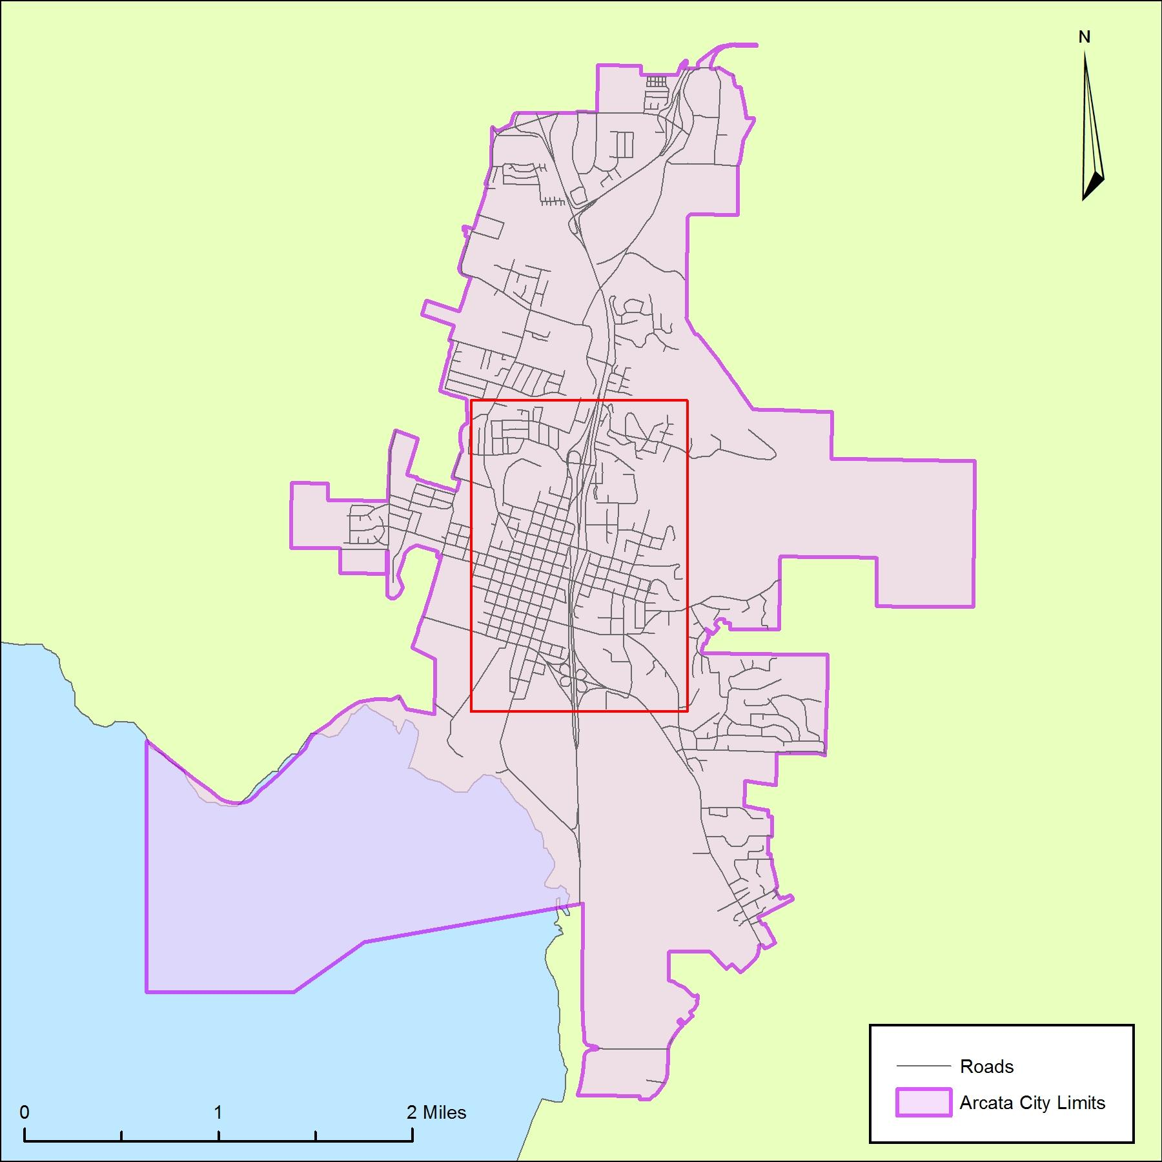
Figure 1. Locator map of Arcata city limits and area of study

Methods
In order to determine what areas have the poorest lighting, datasets for Humboldt County, Arcata city boundaries, parcels, roads, and railroads were downloaded from the Humboldt County website. National Agriculture Imagery Program imagery files were downloaded from HSU’s geospatial department database. Preparation of the maps was accomplished using ESRI’s ArcMap 10.2, as well as Adobe Illustrator. The maps were examined to confirm the spatial references utilized, and then projected to a North American Datum 83, Universal Transverse Mercator, Zone 10 north, projection.

Data Collection
The datasets needed to accomplish our goal included:
- Arcata city limits
- City parcels shapefile
- City roads shapefile
- Railroads
- NAIP imagery
- Light post data
The City of Arcata light post data was obtained from the City of Arcata Geographic Information Systems (GIS) department. This dataset included every light post for the city, except for those that are on private property and on Humboldt State’s campus.

Digitizing

For the HSU campus light posts, we created our own dataset by mapping every location on foot and marking them on a basic reference map of the campus. That information was then digitized onto a NAIP image of Humboldt County in ArcMap.
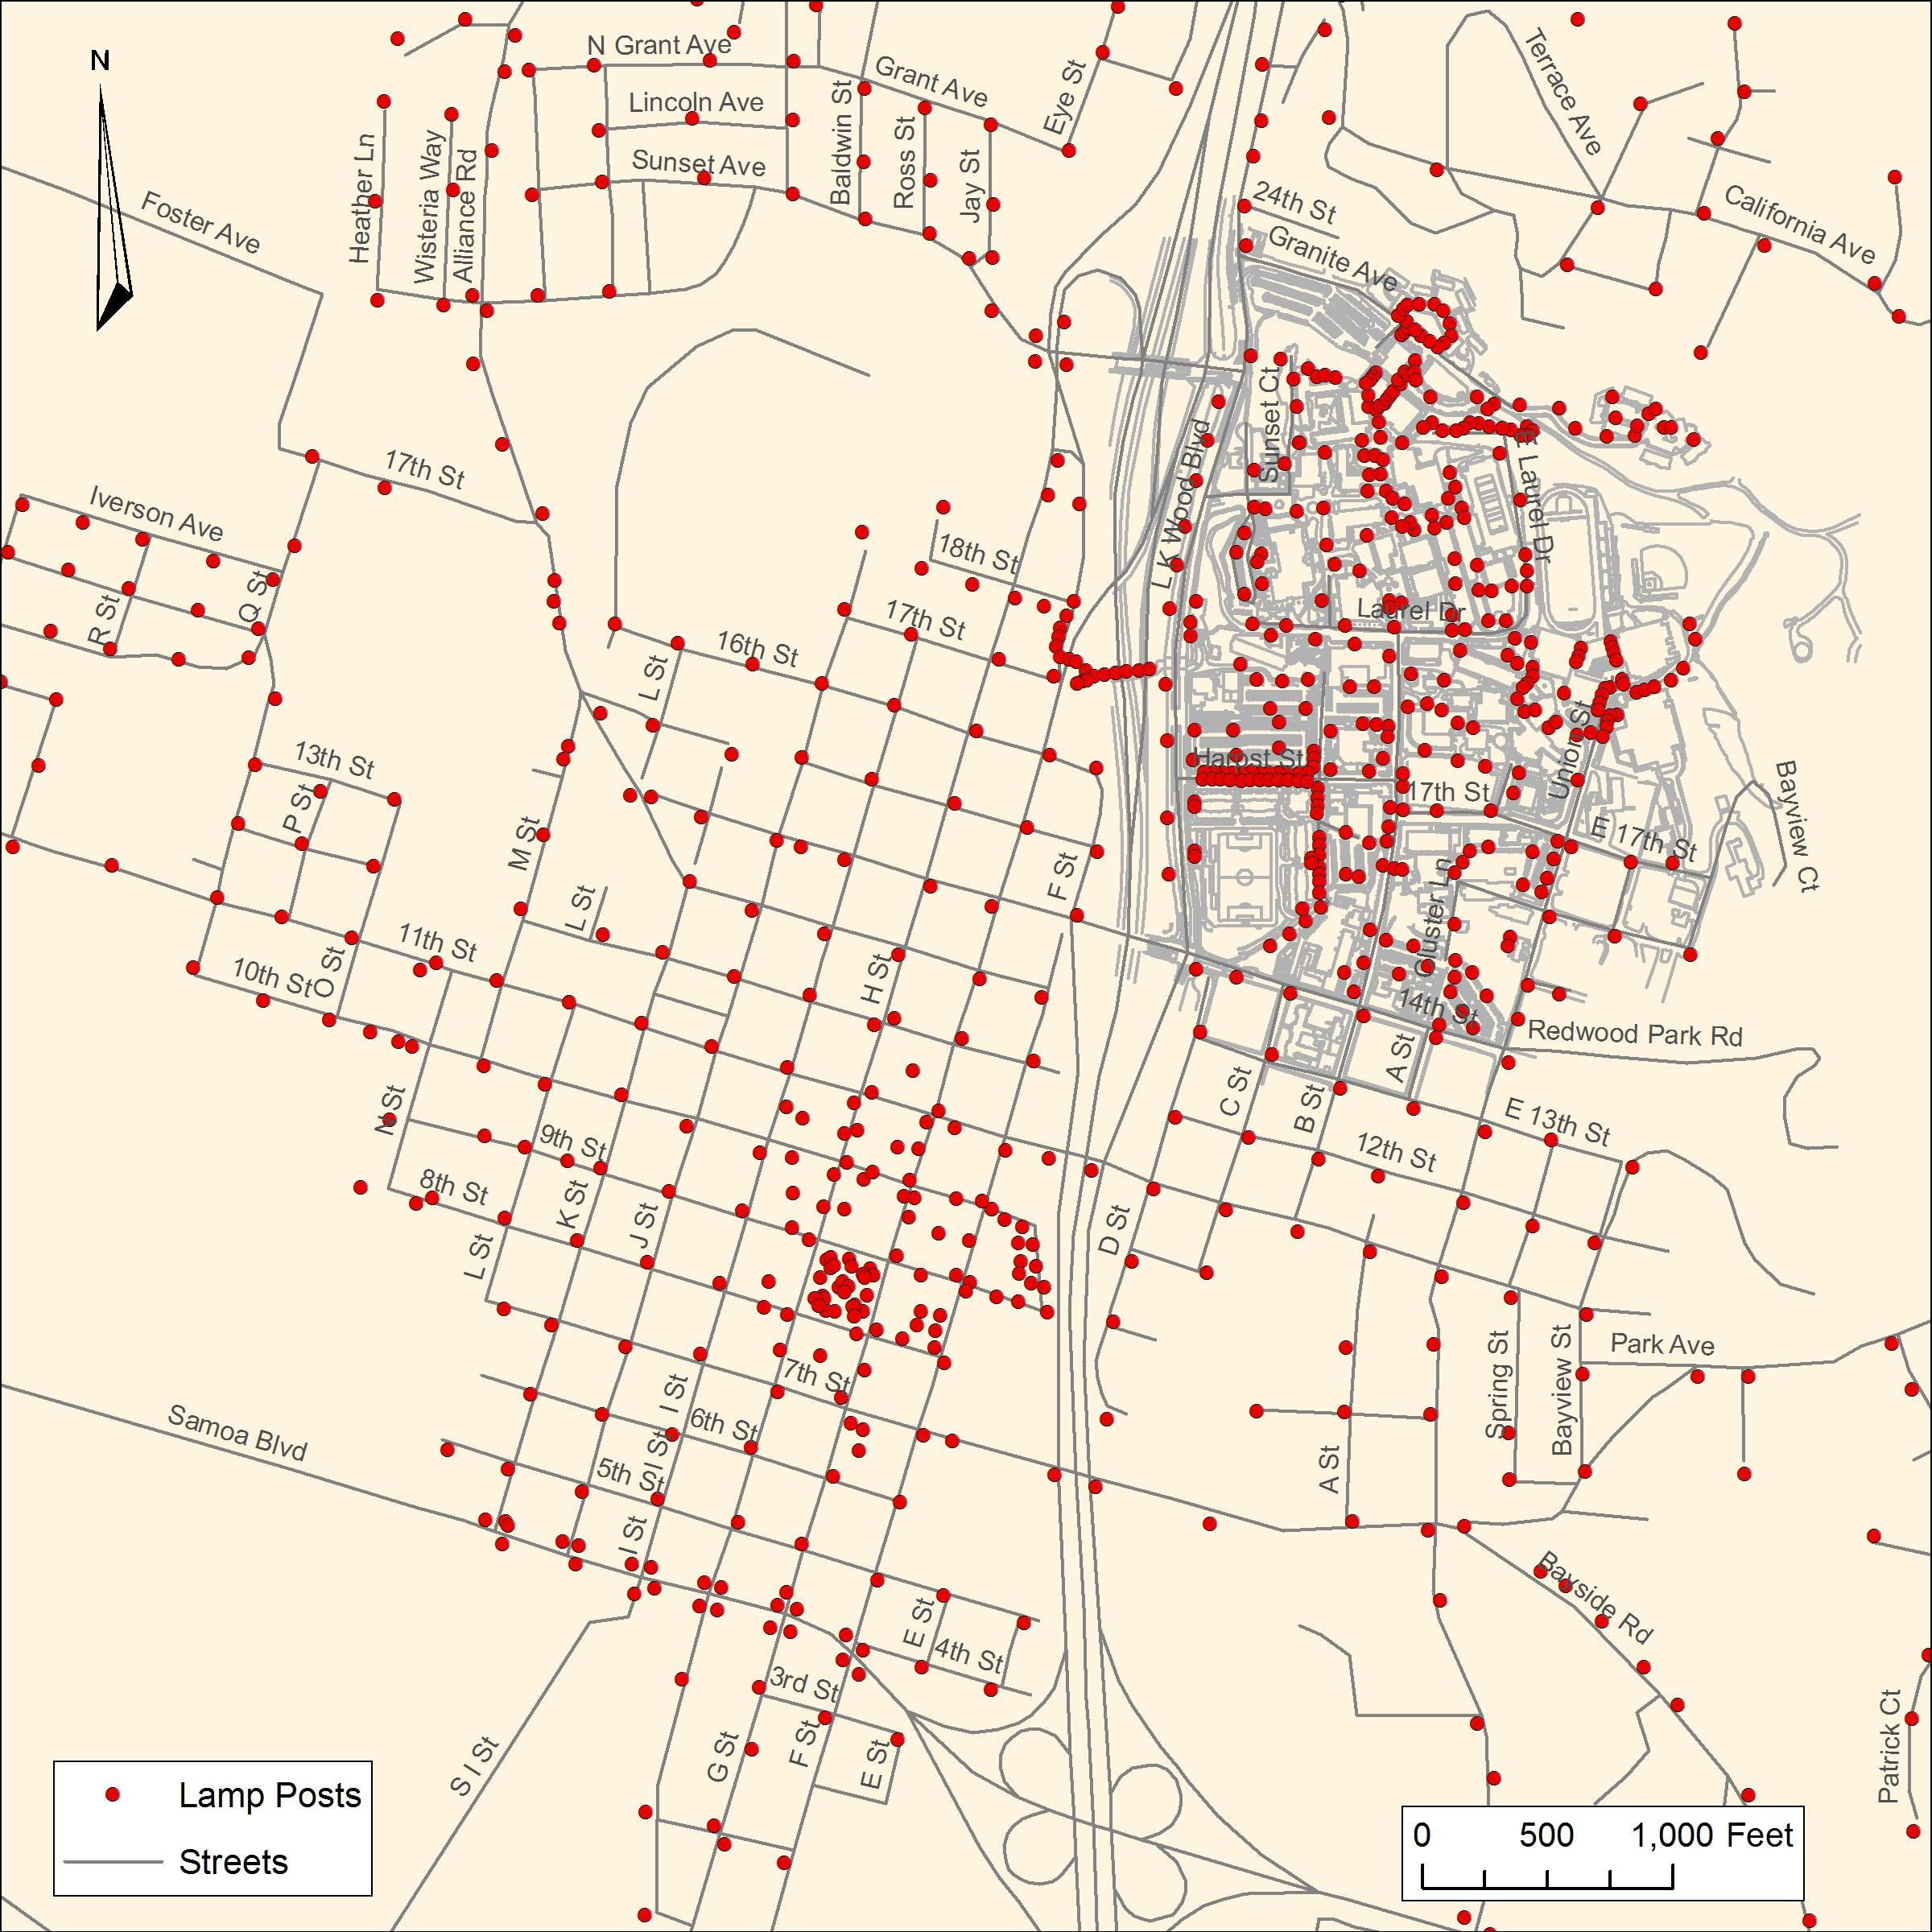
Figure 2. Map depicting all lamp post data acquired for Arcata and Humboldt State University

Sampling

Since not every lamp post has the same radius of light, we chose to sample random light posts in Arcata and HSU for an average illuminated distance. By doing this, we are able to set buffers for each dataset based on the average radius of light for each dataset.
First, we had to determine our sample extent, since we are primarily interested in the lights immediately in the downtown area of Arcata. We determined that these streets qualified for our sample:
- Streets that are Letters and Numbers
- Lk Wood Blvd
- Any street on HSU
- Union Street
- Samoa Blvd.
After selecting all of these streets in ArcMap, a 50 foot buffer was created around them. Any light posts that were within this buffer are now our sample lights. Next, a random sample for the Arcata light post data was created (10% of the light posts) by sorting the light posts by a non-geographically sorted attribute, and selected the first 30 features that appeared. (Figure 3)
Since the HSU light posts were digitized ourselves and were placed on the map in a geographic order, a random sample was acquired by exporting the features into Microsoft Excel and creating an equation that would randomize the features. Those numbers were then imported back into ArcMap and the first 30 that appeared in the attribute were selected. (Figure 4)

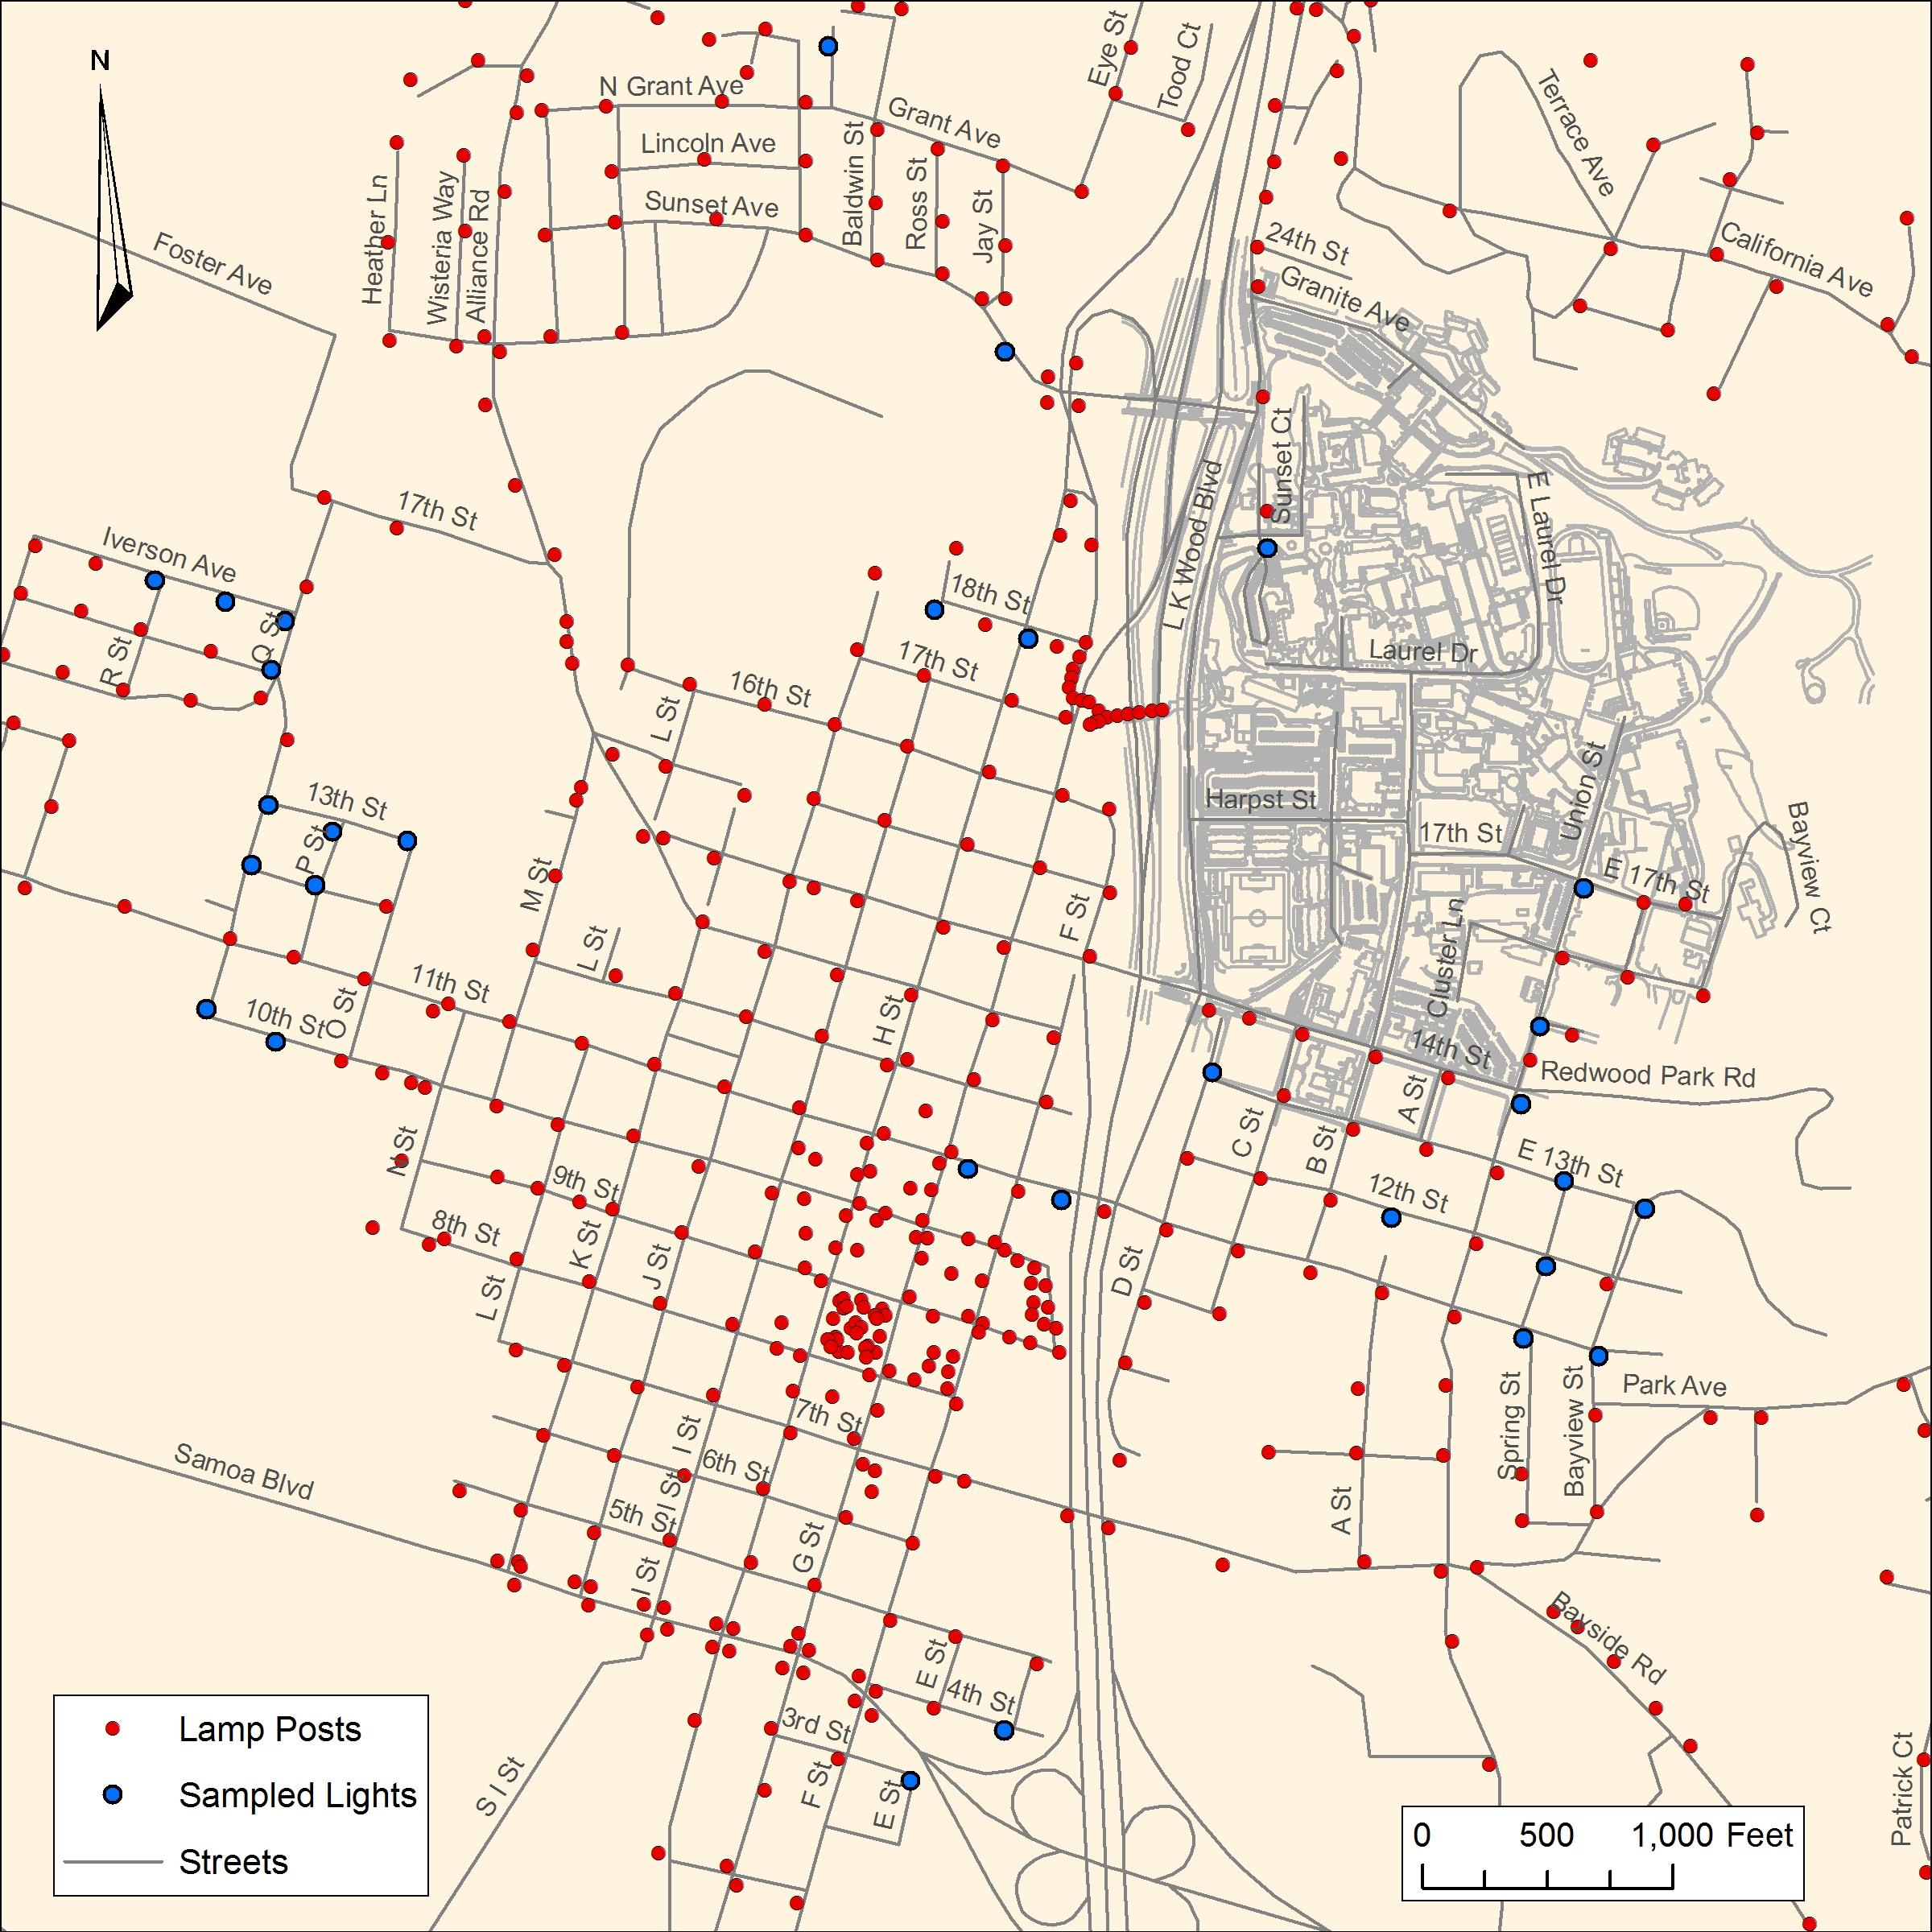

Figure 3 . Map depicting random sample of lamp posts in downtown Arcata

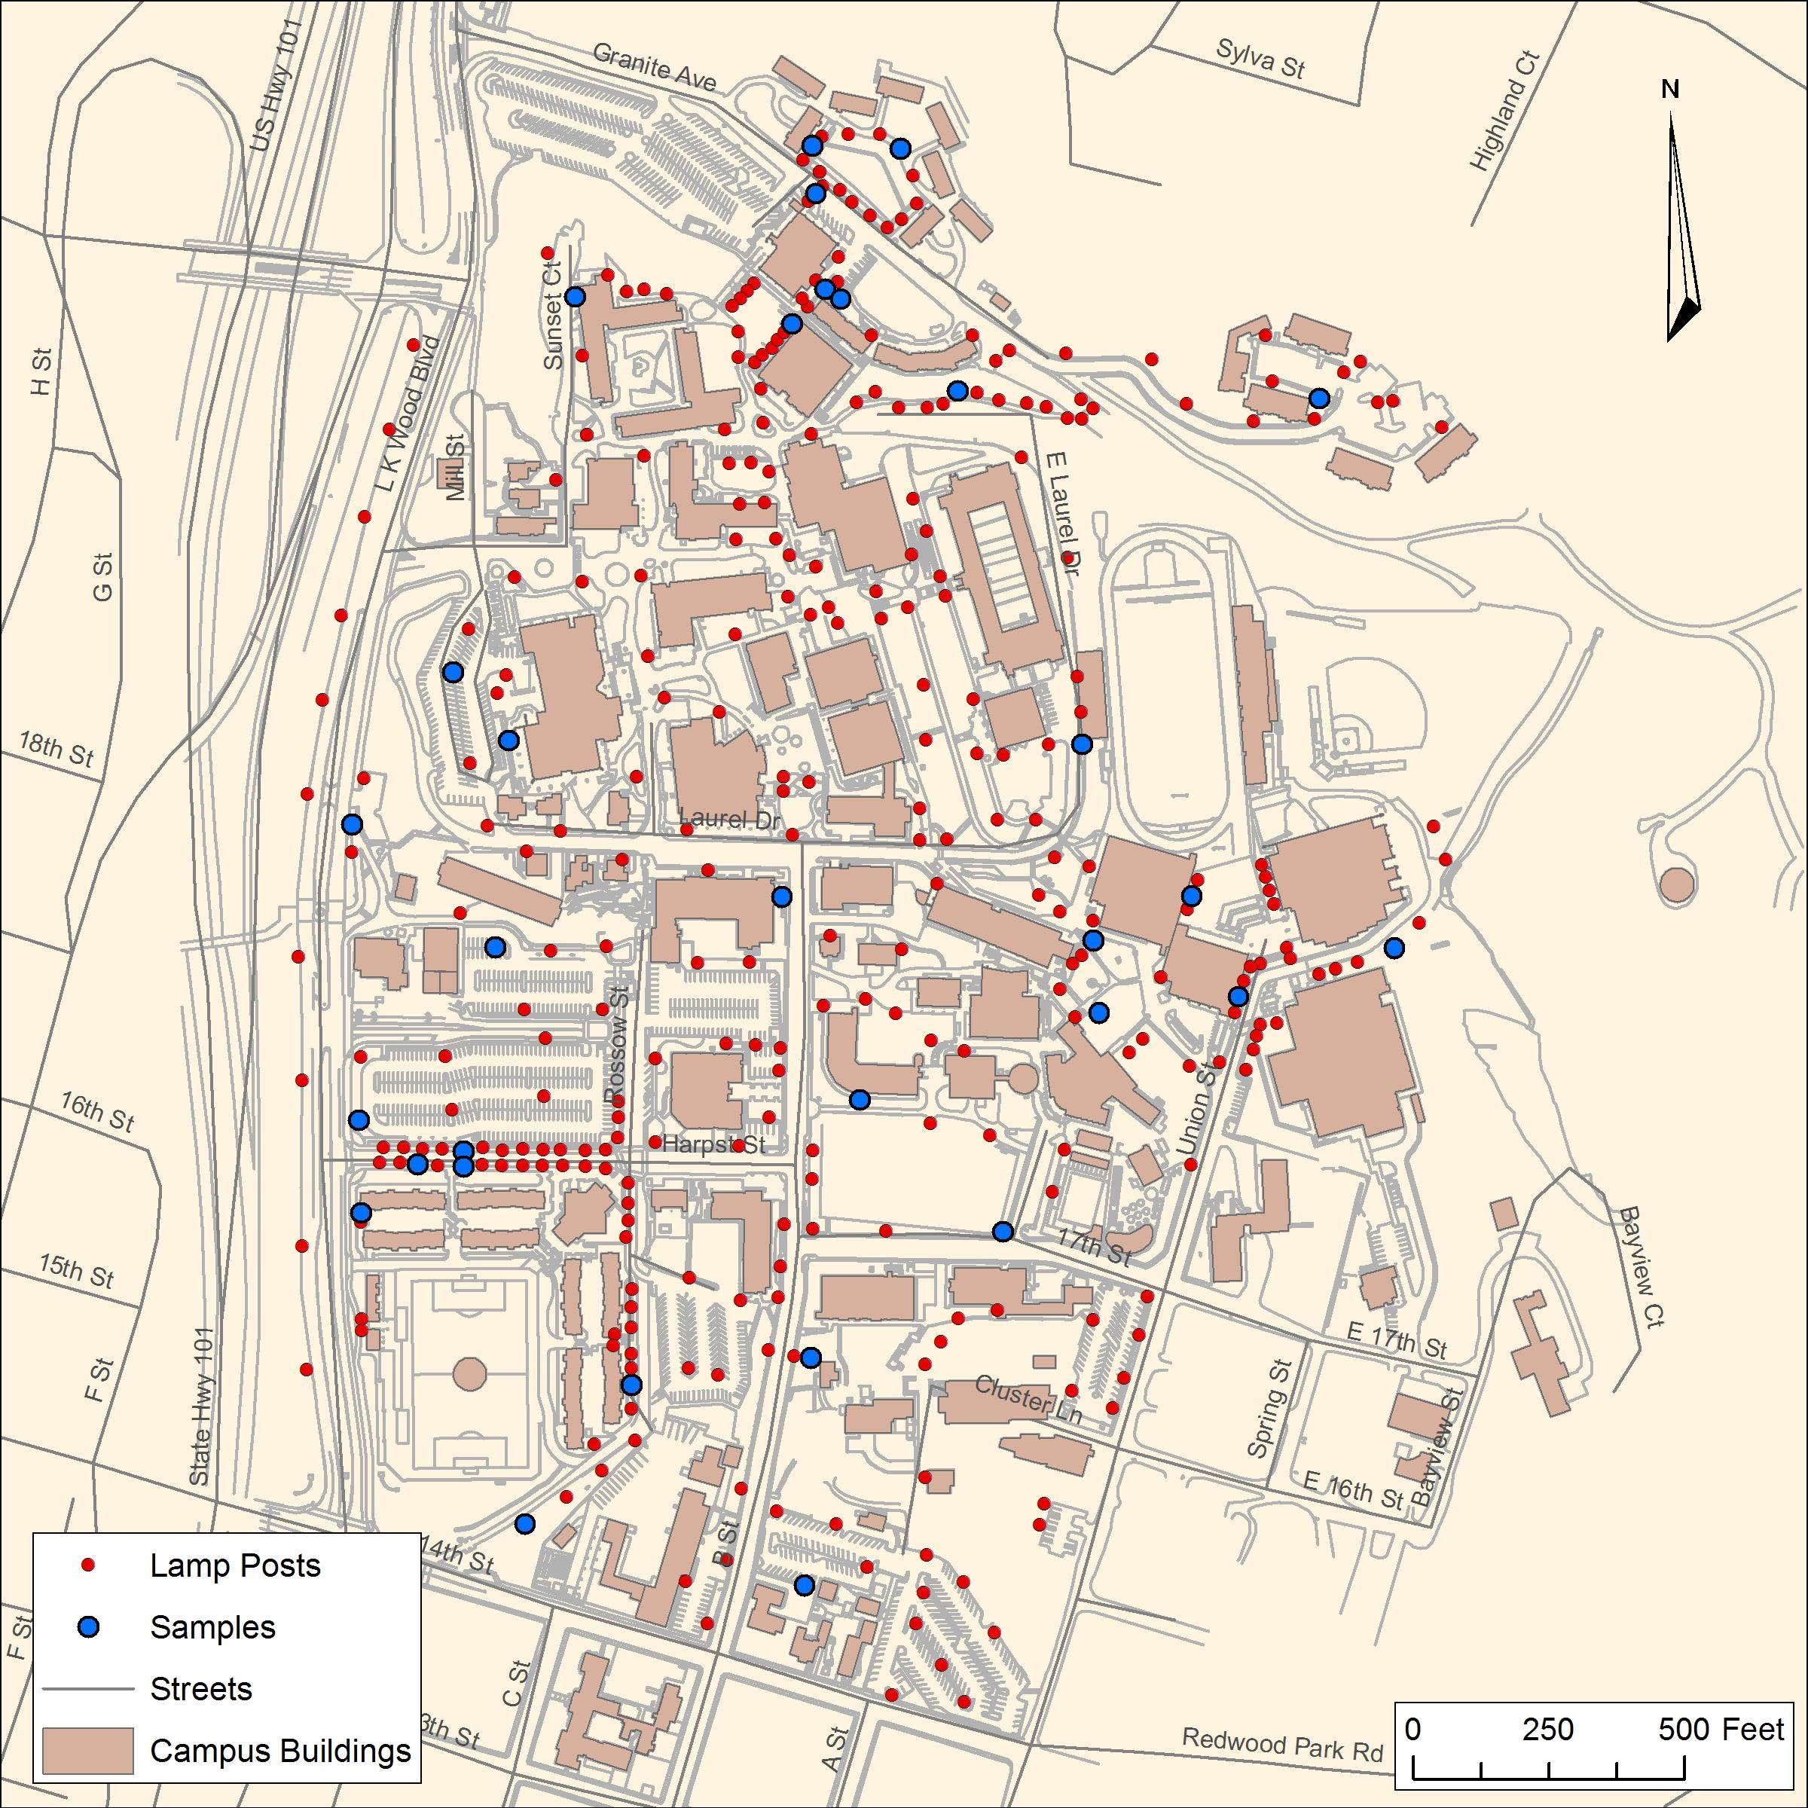

Figure 4. Map depicting random sample of lamp posts on Humboldt State University

Table 1. Number of light posts sampled and their average recorded radius in feet
 | Approximate Radius of Lamp Posts (ft.)
 | City of Arcata Light Posts | HSU Light Posts
Total Light Posts | 369 | 328
# of Samples taken | 30 | 30
Average Radius: | 35.68965517 | 29.06896552

Buffer around each light post
- HSU average: 29 feet
- Arcata average: 35 feet

Results
The results found through this mapping process reveals that throughout the HSU campus, as well as in nearby downtown Arcata, there are few locations that are lacking adequate lighting. The campus itself has a widely distributed network of lamp posts, albeit not in a uniform grid pattern such as in the downtown area. The main location where illumination is lacking would be the area behind the Redwood Bowl football field. This segment of street/path that continues past the dormitories along Granite Avenue is known as the “Granite extension,” and according to campus police is an area that some retreat to for illicit activities including the use of drugs and alcohol. These activities would appear to be heightened as a place of “refuge” due to the absence of lighting along this trail, and would be a section of pathway that a wary individual might consider avoiding.

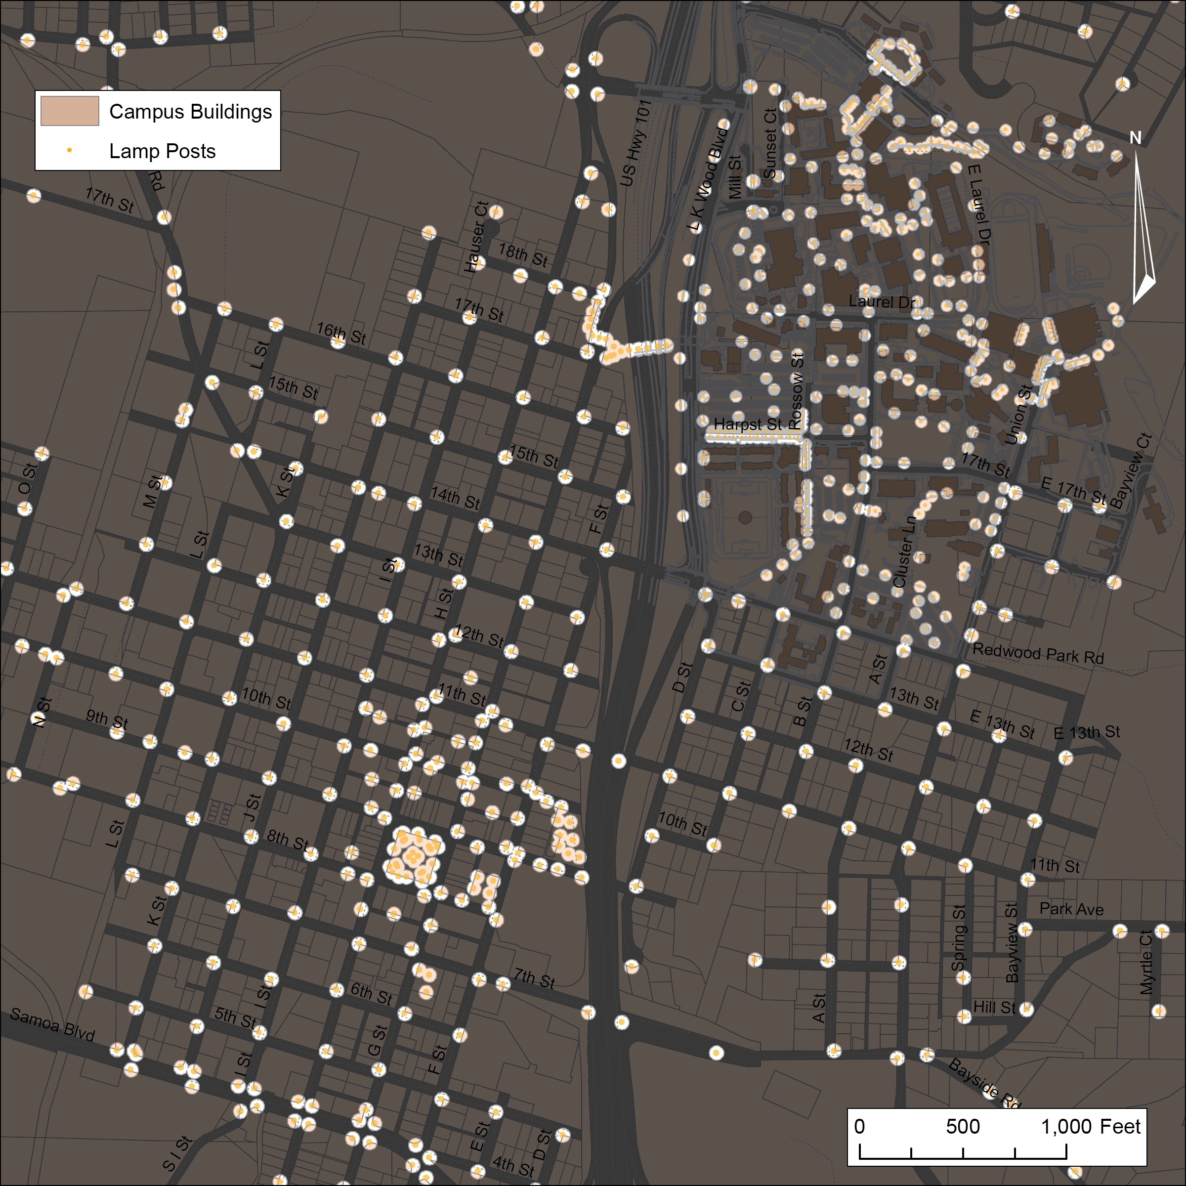
Figure 5. Illumination in downtown Arcata.

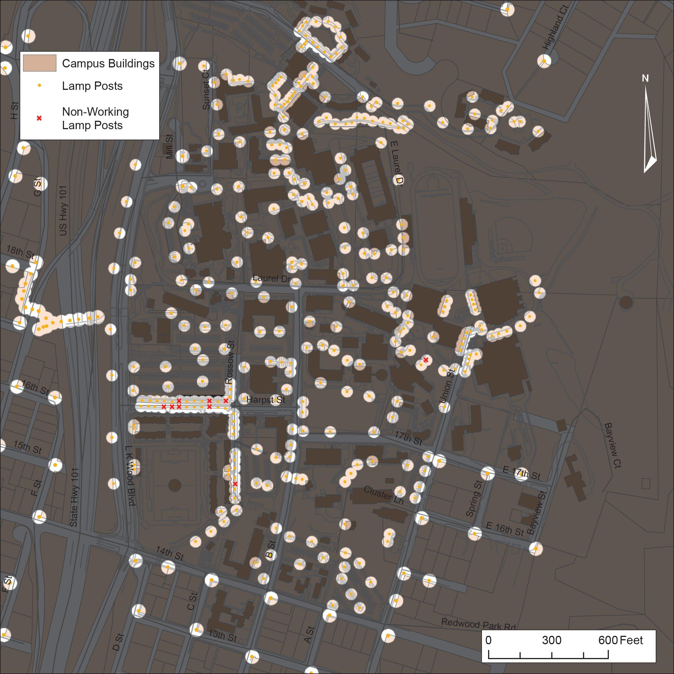
Figure 6. Illuminated areas on Humboldt State’s campus.

Conclusion
Our lamp mapping project revealed that the majority of downtown Arcata as well as Humboldt State University itself have a well-distributed lighting network altogether. There are sections with more lighting, such as downtown around the Arcata Plaza as well as L.K. Wood Boulevard along the western edge of HSU campus, and Granite Street (also known as “The Canyon” where there are dormitories to the north of campus grounds. As a comparison, the northeast section of the college has a pathway called “Granite Extension” which has an absence of lamp posts, and as a result is very poorly lit. This area is known by campus police as a place for some to congregate who may drink alcohol or smoke marijuana, and would be a good area to avoid for safety concerns.

Uncertainty:
The lamp posts surveyed ranged in height based on whether their main function was for pedestrian or street use.
Lights were sampled on different nights between April 23rd and 26th, during different weather conditions.
The full radius of light may have been obstructed in areas by trees, buildings, and/or other lights.
Lights from buildings and city parking lots are not included in the analysis.
Not all lamp illumination radii were identical, and averages were equated.

Acknowledgements
Brian Kang, City of Arcata GIS for providing the city of Arcata streetlight shapefile.
Joselyn Adema, Holly Lemyre and Andrea Taylor, for helping measure light distances

Bibliography
"Lighting Use & Design - Project For Public Spaces". Project for Public Spaces. N.p., 2016. Web. 28 Apr. 2016.

Morris, Nina J. "Night Waking: Darkness And Sensory Perception In A Night-Time Landscape Installation." Cultural Geographies 18.3 (2011): 315-342. Academic Search Premier. Web. 28 Apr. 2016.

